# DECLARATION

I, **Stanley Justine Mahenge**, declare to the best of my knowledge that the project presented here, as partial fulfillment of a Bachelor Degree in Computer Engineering, is my work and has neither been copied anywhere nor presented elsewhere.

**CANDIDATE NAME SIGNATURE DATE**

STANLEY JUSTINE MAHENGE _________________ ______________

**SUPERVISOR NAME SIGNATURE DATE**

DR NKUNDWE MOSES MWASAGA _________________ ______________

# ABSTRACT

In Tanzania, the health service is faced with challenges of inadequate funds, a shortage of fully trained health staff in the hospitals, poor communication, and transport infrastructure. The challenges hinder the development plans of Tanzania's health system, including the Sustainable Development Goal. All of these challenges have been associated with the fact that Tanzania is still a developing country with a limited budget to finance all of the development initiatives. Therefore, there is always a burden to healthcare providers on handling large numbers of patients admitted in the wards of hospitals.

In line with that, the proposed system came up with a cost effective system on MONITORING THE HEALTH STATUS OF PATIENTS that measure and track both temperature and blood pressure of patients. Using technology such as the internet of things and artificial intelligence the system shall manage vital signs data of patients in real-time. With the help of temperature and blood pressure sensors that a patient shall wear, data shall be tracked and captured then taken to a microcontroller that will forward them to the monitoring terminal of a nurse. This terminal shall feed individual patients records to the Hospital data pools where the artificial web portal shall be used to analyze and evaluate the data. In case there is a critical condition on any patient managed by the system, a notification will be sent to an attending healthcare giver if no response in one minute of emergency handler shall be notified.

The system shall be useful to healthcare providers and will increase the monitoring of patients by doctors. The case study of the system is in Jakaya Kikwete Cardiac Institute. Evaluation of the patient records shall be using graphical representation that is attained through the use of artificial Intelligence. With the help of statistical data analyzed through data collected from the field of study, it has been found that the proposed system proved to be effective and worthy of monitoring patient health during their working shifts.

# ACKNOWLEDGMENT

First and foremost, I would like to thank God for the privilege to do this project while pursuing a Bachelor of Computer Engineering degree at Dar es Salaam Institute of Technology.

I would like to express my special thanks to my Supervisor Dr. Nkundwe Moses Mwasaga. He provided invaluable advice and helped me in difficult periods. His motivation and help contributed tremendously to the successful completion of the project.

Besides, I would like to thank all the Lecturers who helped me by giving me advice and providing the guidance which I needed.

Also I would like to thank my family, friends and classmates for their support. Without that support I couldn’t have succeeded in completing this project.

Last but not least, I would love to thank everyone, especially nurses and doctors from Jakaya Cardiac Institute who provided their precious incentive , help and motivated me to work on this project.

# TABLE OF CONTENTS

DECLARATION 3

ABSTRACT 4

ACKNOWLEDGMENT 5

TABLE OF CONTENTS 6

LIST OF ABBREVIATIONS 8

LIST OF FIGURES 9

LIST OF TABLES 10

CHAPTER ONE 1

INTRODUCTION 1

1.0 BACKGROUND INFORMATION 1

1.1 PROBLEM STATEMENT 1

1.2 OBJECTIVES 1

1.2.1 MAIN OBJECTIVES 2

1.2.2 SPECIFIC OBJECTIVES 2

1.3 SIGNIFICANCE OF THE PROJECT 2

1.4 SCOPE OF THE PROJECT 2

1.5 PROJECT CONTENTS 3

1.5.1. Sensing Modules. 3

1.5.2. Micro-controllers subsystem 4

1.5.3. AI-based Web portal subsystem 6

1.5.4. Alerting subsystem 7

1.6 CHAPTER SUMMARY 7

CHAPTER TWO 8

2.0 LITERATURE REVIEW 8

2.1 EXISTING SYSTEM 9

2.1.1 COMPONENTS OF EXISTING SYSTEM 9

2.1.2 LIMITATION OF EXISTING SYSTEM 12

2.2 PROPOSED SYSTEM 12

2.2.1 The proposed system shall have the following component: 14

2.3 CHAPTER SUMMARY 15

CHAPTER THREE 16

METHODOLOGY 16

3.0 INTRODUCTION 16

3.1 DEVELOPMENT METHODOLOGY 16

3.1.1 The technical reason for using prototyping 16

3.1.2 Tools for prototyping 17

3.1.3 Prototype method model 17

3.2 DATA COLLECTION 18

3.2.1 AREA OF STUDY 19

3.2.2 POPULATION AND SAMPLE SIZE 20

3.2.3 QUESTIONNAIRE AND INTERVIEW RESULTS 20

3.3 CHAPTER SUMMARY 24

CHAPTER FOUR 25

4.0 RECOMMENDATION 25

4.1 PROJECT COST ESTIMATION 25

4.2 ESTIMATED TIMELINE 26

REFERENCE 27

APPENDIX A 28

APPENDIX B 29

APPENDIX C 30

# LIST OF ABBREVIATIONS

**WHO** – WORLD HEALTH ORGANIZATION

**ECG** – ELECTRO-CARDIOGRAPH

**EEG** - ELECTRO-ENCEPHALOGRAM

**BP** – BLOOD PRESSURE

**ADC –** ANALOG-DIGITAL CONVERTER

**MCU –** MICROCONTROLLER UNIT

**USB –** UNIVERSAL SERIAL BUS

**IA –**  ARTIFICIAL INTELLIGENCE

**IoT –** INTERNET OF THINGS

**IS –** INFORMATION SYSTEM

**AVR –** AUTOMATIC VOLTAGE REGULATION

# LIST OF FIGURES

Figure 1Temperature Sensor 1 12

Figure 2Pressure Sensor 13

Figure 3Node MCU 14

Figure 4Arduino IDE 15

Figure 5Mercury Thermometer 19

Figure 6Blood Pressure Cuffs 20

Figure 7Data Flow Existing System 20

Figure 8 Data Flow Existing System 22

Figure 9 Prototyping Methodology 25

Figure 10 Jakaya Kikwete Cardiac Institute 28

Figure 11 Pie Chart 1 29

Figure 12 Pie Chart 2 29

Figure 13 Pie Chart 3 30

Figure 14 Pie Chart 4 30

Figure 15 Pie Chart 5 31

Figure 16 Pie Chart 6 32

**Figure** 17 Use case 34

Figure 18 36

Figure 19 Figure 20 Figure 21 39

Figure 22 Figure 23 39

Figure 24 Figure 25 40

Figure 26 42

Figure 27 42

Figure 28 43

Figure 29 44

Figure 30 44

Figure 31 45

Figure 32 46

Figure 33 46

Figure 34 47

Figure 35 48

# LIST OF TABLES

Table 1 Functional Requirement 32

Table 2 Non Functional requirement 33

Table 3 Node MCU Technical specifications 37

Table 4 Cost Estimation 49

Table 5 Project Timeline 50

CHAPTER ONE

# INTRODUCTION

## BACKGROUND INFORMATION

According to World Health (WHO), the doctor to patient ratio in Tanzania is around 1:20000 where the average ratio is 1:300. The ratio means one doctor has to attend around 98% more than the average. However, to date, there are highly technological and expensive systems that are used for monitoring patients in Hospitals. Some of the systems are ECG for heart rate monitoring, EEG for monitoring brain activities etc. these systems are quite expensive.

Thus, the proposed study comes with a minimally designed and cost-effective system for the doctors to be able to effectively and instantly trace multiple patients' healthy status that is the patient's temperature and pressure within the hospital during his work session. The case of study for this proposed system is at Jakaya Kikwete Cardiac Institute. Generally, even for regional Hospital wards of Tanzania, the number of patients admitted is too large for health care provided to attempt taking care of all of them instantly and addressing the critical condition of a patient as soon as possible.

## PROBLEM STATEMENT

The smaller doctor to patient ratio indicates that there is a heavy burden on the doctors and healthcare providers in following up the healthy status of each individual patient admitted in Ward. Moreover, large distance between patient and physicians hinder the quality of health services as this in most cases is the matter of death and life

## OBJECTIVES

The objectives of this proposed system are as follows, the main objective as the whole aim of accomplishing this project and the specific objective as to how the project is going to be implemented from the initial stage to final where the modules are classified as simple as possible to accomplish the main objective.

### 1.2.1 MAIN OBJECTIVES

* To develop a low cost-effective and flexible patient health status monitoring system using the Internet of things. The system shall help the healthcare Giver to get the time to time temperature and pressure of patients admitted in the wards.

### 1.2.2 SPECIFIC OBJECTIVES

* To develop a gadget of wireless temperature and pressure sensors which will be as close as possible to the patient to mine requires patient data.
* To develop physician terminal and attending healthcare giver terminals where patients data shall be processed to be sent to the Hospital data pool.
* To build a database driven web portal were patients data shall be stored , analyzed and evaluated

## 1.3 SIGNIFICANCE OF THE PROJECT

* The proposed system shall be able to provide the real-time remote monitoring of the

Heartbeat and temperature with the integration of a way to notify the nurse about patients

Condition and SMS to a doctor to notify him/her about the abnormal condition of the patient.

* The appropriately proposed system shall be useful to regional hospitals (or any other

Medical service center) where a lot of patients are admitted.

* The system shall aim at reducing the distance between the patient and his attending

Physician by allowing the healthcare giver to have the analyzed temperature and pressure

Of patients at their fingertips.

## 1.4 SCOPE OF THE PROJECT

The patient health status monitoring system will focus on providing the healthcare giver the real time patient’s temperature and pressure that is evaluated using a web portal during his/her working shift. The data that shall be provided shall be effective for any critical condition facing the patient in such a way that the system by itself it shall notify the healthcare giver on who is the patient that is under such condition and which ward is he/she admitted even the bed number that the patient is sleeping, In case a notifying system is not responded the system will send the notification to the upper level in Hospital administration hierarchy.

## 1.5 PROJECT CONTENTS

The proposed system shall consist of four subsystems that are sensing systems, microcontrollers, web portal system and the alerting system.

### 1.5.1. Sensing Modules.

A sensor is a device that produces an output signal for the purpose of sensing a physical phenomenon. In the broadest definition, a sensor is a device, module, machine, or subsystem that detects events or changes in its environment and sends the information to other electronics, frequently a computer processor. Sensors are always used with other electronics.

A sensor's sensitivity indicates how much its output changes when the input quantity it measures changes. For instance, if the mercury in a thermometer moves 1 cm when the temperature changes by 1 °C, its sensitivity is 1 cm/°C (it is basically the slope dy/dx assuming a linear characteristic). Some sensors can also affect what they measure; for instance, a room temperature thermometer inserted into a hot cup of liquid cools the liquid while the liquid heats the thermometer. Sensors are usually designed to have a small effect on what is measured; making the sensor smaller often improves this and may introduce other advantages.

Temperature sensors are a simple instrument that measures the degree of hotness or coolness and converts it into a readable unit. Well, this is accomplished through some of the specialized temperature sensors.

The basic principle of working of the temperature sensors is the voltage across the diode terminals. If the voltage increases, the temperature also rises, followed by a voltage drop between the transistor terminals of base and emitter in a diode. Besides this, Encardio-Rite has a vibrating wire temperature sensor that works on the principle of stress change due to temperature change.

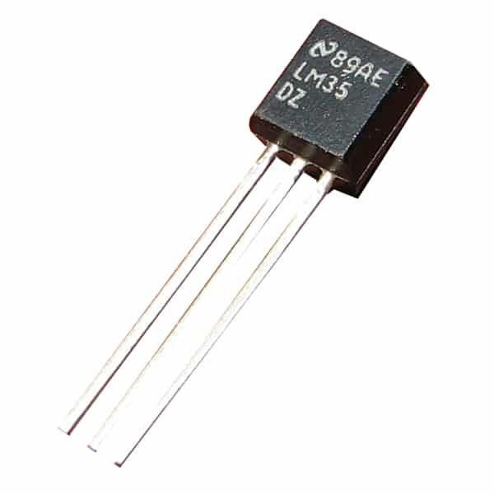

Figure Temperature Sensor 1

Blood Pressure (BP) is one of the important vital signs. It is the pressure exerted by the circulating blood on the walls of blood vessels. Blood Pressure is expressed as the ratio of the systolic pressure over diastolic pressure. Mercury sphygmomanometer is being used for measuring blood pressure. In this, the height of the column of mercury is considered for measuring the blood pressure. With the advance in technology, devices for measuring blood pressure through the non-invasive oscillometric method are being developed. One such device is the Blood Pressure Sensor.

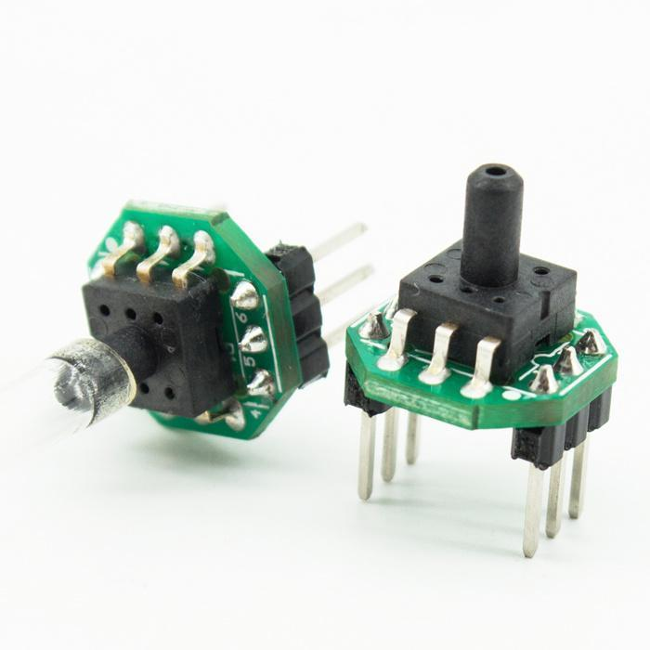

Figure Pressure Sensor

### 1.5.2. Micro-controllers subsystem

All microcontrollers contain a processor that executes code and a set of circuits called 'peripherals' that provide additional functions: USB, serial interfaces, ADCs, timers, and so on. The biggest difference between microcontrollers is the relationship between the processor, the peripherals, and the physical pins that come out of the package.

A microcontroller (MCU for microcontroller unit) is a small computer on a single metal-oxide-semiconductor (MOS) integrated circuit (IC) chip. A microcontroller contains one or more CPUs (processor cores) along with memory and programmable input/output peripherals. Program memory in the form of ferroelectric RAM, NOR flash or OTP ROM is also often included on-chip, as well as a small amount of RAM. Microcontrollers are designed for embedded applications, in contrast to the microprocessors used in personal computers or other general-purpose applications consisting of various discrete chips.

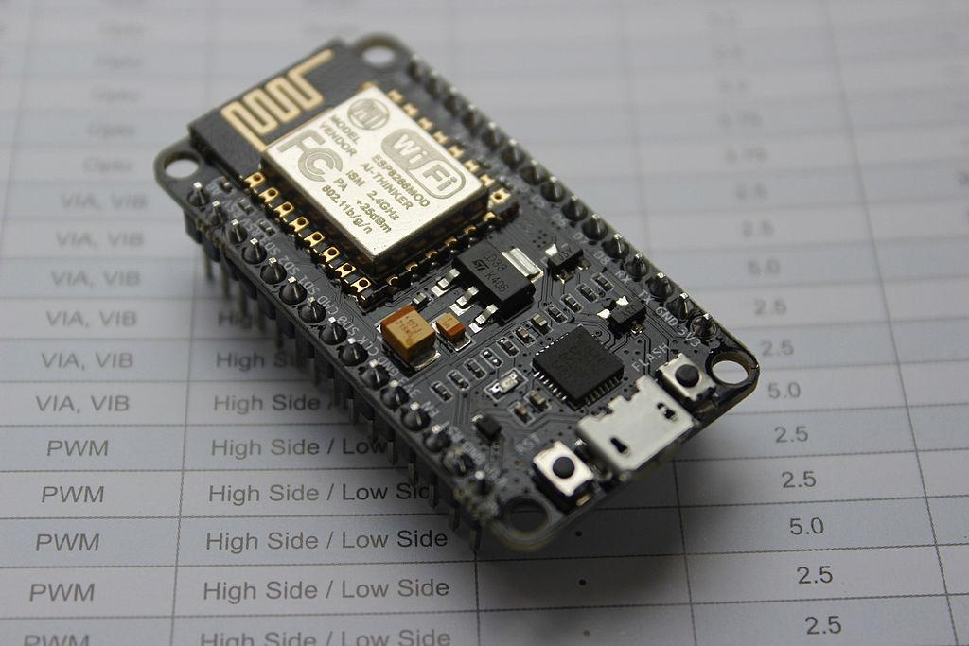

Figure Node MCU

NodeMCU is an open source firmware for which open source prototyping board designs are available. The name "NodeMCU" combines "node" and "MCU" (micro-controller unit). The term "NodeMCU" strictly speaking refers to the firmware rather than the associated development kits.Both the firmware and prototyping board designs are open source.

The firmware uses the Lua scripting language. The firmware is based on the eLua project, and built on the Espressif Non-OS SDK for ESP8266. It uses many open source projects, such as lua-cjson[9] and SPIFFS.[10] Due to resource constraints, users need to select the modules relevant for their project and build a firmware tailored to their needs. Support for the 32-bit ESP32 has also been implemented.

The prototyping hardware typically used is a circuit board functioning as a dual in-line package (DIP) which integrates a USB controller with a smaller surface-mounted board containing the MCU and antenna. The choice of the DIP format allows for easy prototyping on breadboards. The design was initially based on the ESP-12 module of the ESP8266, which is a Wi-Fi SoC integrated with a Tensilica Xtensa LX106 core, widely used in IoT applications (see related projects).

For the proposed system Node MCU is programmed using Arduino Software in which a cross-platform application called IDE is written in Java. The AVR microcontroller Atmega328 laid out on the base comes with a built-in bootloader that sets you free from using a separate burner to upload the program on the board.

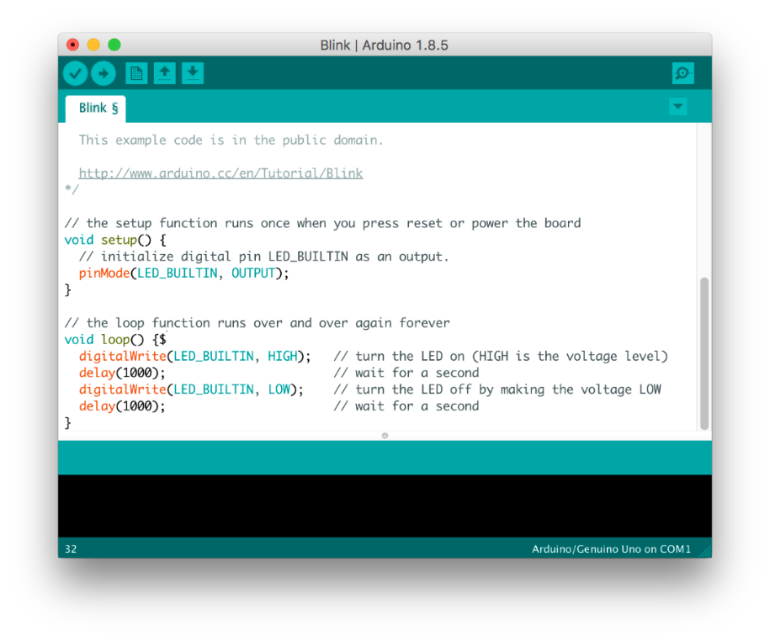

Figure Arduino IDE

### 1.5.3. Database Driven Web portal subsystem

Web information system, or web-based information system, is an information system that uses Internet web technologies to deliver information and services to users or other information systems/applications. It is a software system whose main purpose is to publish and maintain data by using hypertext-based principles.

The intelligent web, also often referred to as Web 3.0, involves the idea that World Wide Web pages, sites, and applications will continue to be imbued with artificial intelligence. Some of the groundwork of the intelligent web has already been laid – with protocols like JSON and the semantic web, there is a skeleton system in place for sharing data and managing data repositories in new ways. At the same time, artificial intelligence and machine learning are reinventing software. Cloud and software as a service are bringing those applications to the web.

As for the proposed system that patient real time temperature and pressure shall be evaluated and analyzed using this kind of web portal.

### 1.5.4. Alerting subsystem

Notification system, a combination of software and hardware that provides a means of delivering a message to a set of recipients. A system that allows alert messaging, machine-to-person communication that is important or time-sensitive. Emergency communication system, any system organized for the primary purpose of supporting communication of emergency information.

Instead of devoting IT resources to monitoring systems and processes, automated notification can do the job for you. When events occur, automated alerts are sent to the appropriate staff, taking into account whether they are on duty, on-call, or out of office, allowing recipients to quickly fix problems before they cause downtime or delays. Automated notification has proven to be an invaluable tool for incident management, quickly delivering a recognizable return on investment by reducing response time for IT incidents. These benefits are not unique to the IT department, and can provide great value when extended throughout the enterprise, ultimately helping to streamline business operations, increase efficiency and enhance productivity.

Reach staff wherever they are.

## 1.6 CHAPTER SUMMARY

This chapter focuses on introducing the scenario of regional hospital services of Tanzania and the fact that the patient to doctor ratio is 1:20000 according to WHO. It shows the problem statement of the proposed system which is the heavy burden facing healthcare giver in the regional hospital for the case study is Jakaya Kikwete Cardiac Institute. For more the chapter explores the main to specific objectives of the proposed system. Significance of the proposed system are elaborated too in the chapter as the proposed system will come to reduce the heavy burn on healthcare giver and gives the accurate monitoring of patient's health when admitted in the hospital. At last the chapter, elaborate the scope of the proposed system and the Project contents from Sensing abilities all the way to data evaluation and analysis.

# CHAPTER TWO

## 2.0 LITERATURE REVIEW

The Internet of Things (IoT) is a newly emerging term for the new generation of the Internet which allows understanding between interconnected devices. IoT acts as an assistant in healthcare and plays an extremely important role in wide scopes of medicinal services observing applications. [1]

The exponentially growing healthcare costs coupled with the increasing interest of patients in receiving care in the comfort of their own homes have prompted a serious need to revolutionize healthcare systems. This has prompted active research in the development of solutions that enable healthcare providers to remotely monitor and evaluate the health of patients in the comfort of their residences. [2]

Clinical usefulness of existing measures might be demonstrated as clinical experience is broadened. At this time, however, it seems that new instruments, or adaptation of existing measures and scaling methods, are needed for individual-patient assessment and monitoring. [3]

The significant challenge in the implementation of the Internet of Things for healthcare applications is monitoring all patients from various places. Thus the Internet of Things in the medical field brings out the solution for effective patient monitoring at reduced cost and also reduces the trade-off between patient outcome and disease management.[4].

Artificial intelligence (AI) is intelligence demonstrated by machines, as opposed to natural intelligence displayed by animals including humans. Leading AI textbooks define the field as the study of "intelligent agents": any system that perceives its environment and takes actions that maximize its chance of achieving its goals. Artificial intelligence also can be described machines that mimic "cognitive" functions that humans associate with the human mind, such as "learning" and "problem solving", however, this definition is rejected by major AI researchers [6]

An elderly person should be monitored constantly, specifically if he or she has been diagnosed for health-related problems before. In the proposed system, a patient's condition is monitored by using multimodal inputs, specifically, speech and video. Video cameras and microphones are installed in smart homes; these sensors constantly capture video and speech of the patient, and transmit them to a dedicated cloud. [5]

## 2.1 EXISTING SYSTEM

In general, there are existing subsystems that can be wearable things such as bracelets, caps, t-shirts (t-shirts), bands, glasses Wearable processes can be tailored to the "real body." This equipment has been used to contact the person who is to be monitored, personal health and the information gathered which has been sent to the central and internal research Center. Most of these involve monitoring the patient's health by attending physician.

Wearable devices may provide natural statistics, including calories, steps, heart rate, blood pressure; time spent exercising, and so on. The effect on these devices is enormous and of course very strong, which has a good focus on monitoring the physical health of our users.

Considering various wearable devices such as:

**Pulse Oximetry:** This tests the oxygen saturation level of the human body and monitors the difference in the skin blood flow associated with the cardiac cycle.

**Electrocardiography (ECG):** A waveform device that monitors the heart continues to function and provides time information.

**Blood Pressure:** The energy used by blood pumping into the blood vessels helps to quantify it.

**Glucose Monitoring:-**Usually work as a transplant device for body sugar levels tracking.

**Implantable Neural Stimulators:** Adevice for electrical stimulation triggers electric impulses to relieve chronic pain in the human spinal cord or brain.

All of these subsystems work at a level that is not in a case where the physician has to attend and do a follow up on multiple patients. Far from that, the efficiency of these subsystems are not guaranteed. There is no data evaluation and analysis.

### 2.1.1 COMPONENTS OF EXISTING SYSTEM

**Temperature and Pressure Sensing system.**

**Temperature Sensing:** In regional hospitals for the most part the temperature of patients is measured using a mercury thermometer whose accuracy is fairly good except that data cannot be processed digitally and in real-time. In a mercury thermometer, a glass tube is filled with mercury and a standard temperature scale is marked on the tube. With changes in temperature, the mercury expands and contracts, and the temperature can be read from the scale. Mercury thermometers can be used to determine body, liquid, and vapor temperature. Mercury thermometers are used in households, laboratory experiments, and industrial applications.

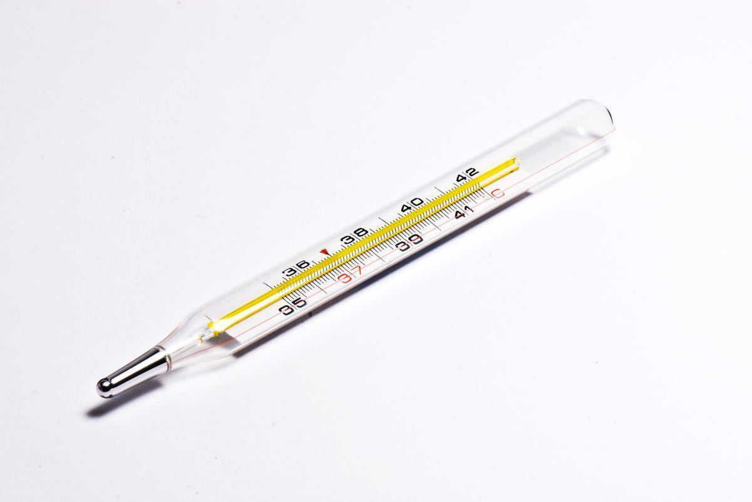

Figure Mercury Thermometer

**Blood pressure Sensing:** Similar to temperature measurement, blood pressure is measured using a sphygmomanometer, which is more often referred to as a blood pressure cuff. The cuff is wrapped around your upper arm and inflated to stop the flow of blood in your artery. As the cuff is slowly deflated, a doctor uses a stethoscope to listen to the blood pumping through the artery. These pumping sounds register on a gauge attached to the cuff. The first pumping sound your doctor hears is recorded as the systolic pressure, and the last sound is the diastolic pressure.

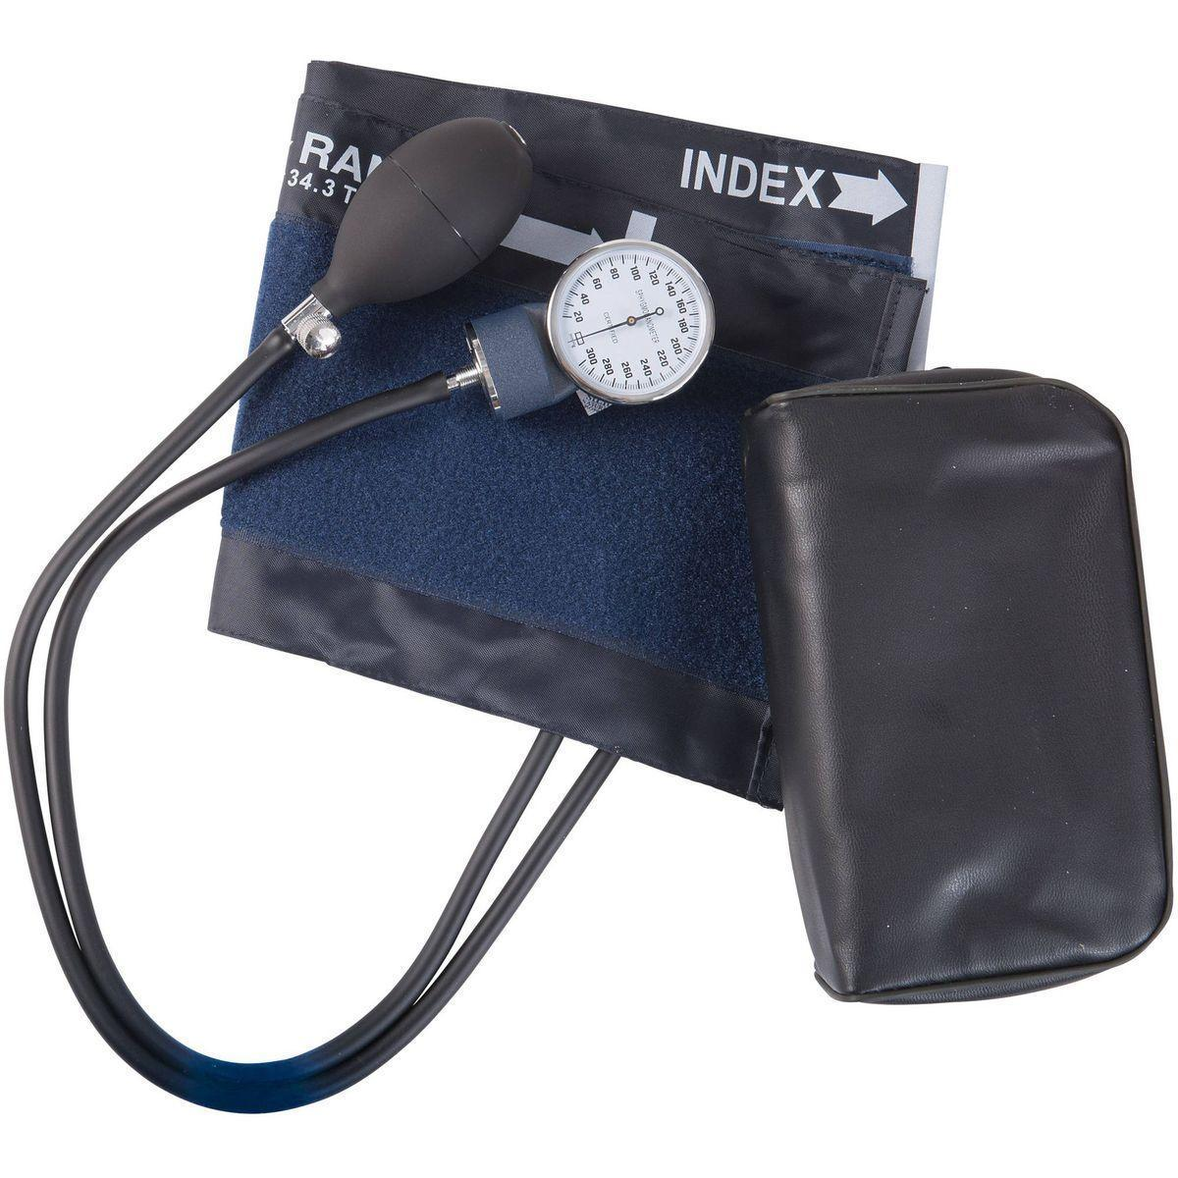

Figure Blood Pressure Cuffs

The Temperature and pressure data measured from the patient are filled into the hospital data pull system by the attending healthcare give and sent to the doctor who plays the role of evaluating the patient conditions and progress.

The patient data flow of the existing system:

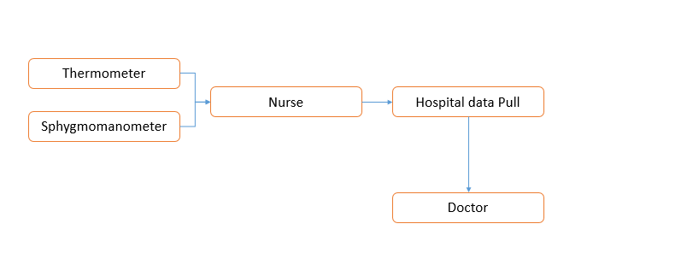

Figure Data Flow Existing System

**Existing system Process:**

Once attending health care, say a nurse admits the patient for the basic data collection the temperature and blood pressure of the patient are read and recorded directly to the hospital system to a particular patient records. The doctor can only view the records and proceed with his/ her professional knowledge to respond to the patient's condition.

### 2.1.2 LIMITATION OF EXISTING SYSTEM

The following are the limitation of the existing system:

* Lack of real time temperature and pressure data of the patients.
* Even when the devices that are used to capture the data of patient are digitized there is no interconnections of devices during both recording process
* Every data depends on exactly what the nurse and healthcare giver feed to the hospital data pull.
* There no artificial intelligence on the data that is stored in the hospital data pull

## 2.2 PROPOSED SYSTEM

IoT refers to the network of physical object-linked devices that allow remote devices to hear, analyze, and monitor. The computational mechanism for linking computer hardware to allow communication between sensors and smart sewing equipment. IoT implementations in IoT data processing rely heavily on the five layers which are perception layer-sensors as data minors, broadcasting layer -transportations and networking, middle layer - processing of data and application layer- analysis.

The role of IoT in healthcare is to reduce maintenance burden, followed by an increase in the chance of healthcare. The additional individual and online health care network was a great learning experience and anticipated that mobile information and general technology killing applications would lead to the development of cloud health services.

The proposed system sensors shall be used to mine patient details that are temperature and pressure. The physician can provide adequate guidance on health care. Increased monitoring is required for IoT devices commonly used for disabled patients. Monitoring strategies, through the assistance of the sensors, have been collected to maintain a constant material movement by the patients referred to there for physicians. In turn, this enhances care quality. In the end, this leads to care costs.

The proposed system shall have a wearable sensor to mine the patient's temperature and blood pressure. With help of wireless networks the individual patient's data shall be moved to the Terminal such as attending Physician and nurse terminal in real-time.

A hospital web portal shall be able to gather and store all admitted patients in all wards, any fluctuation from normal human blood pressure and temperature will automatically result in an alert system as shown in the next flowchart.

### 2.2.1 The proposed system shall have the following component:

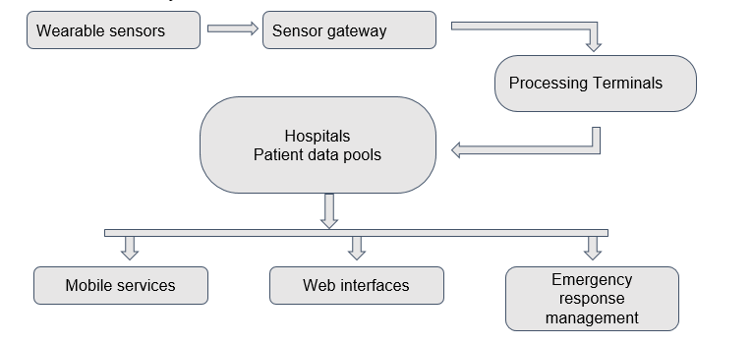

Figure Data Flow Existing System

**Data flow Of Proposed System 8**

* **Wearable Sensor:**

With the proposed system, a patient shall wear a strip with the sensors, in this case temperature and BP sensors which will read the patient data and send to the microcontroller. These sensors will work as data miners and shall effectively be installed in the strip in which the patients admitted in the ward shall wear them.

* **Microcontrollers:**

Microcontroller shall provide a link from sensors to Processing terminals. For the proposed system, Arduino UNO shall be used as a microcontroller that performs all the connections and links the sensors and processing terminal.

* **Processing Terminal:**

Processing terminals shall be computers that are in the hospital wards; these computers shall organize the data from the microcontroller into individual patient data sets. The processing terminal by means of the Internet shall feed these organized patient data to the hospital system as soon as possible. On the other hand, these terminals shall act as the viewpoint of what is on the Hospital information system regarding all patient data.

* **Hospital IS:**

Hospital Information System (IS) is a web portal with government servers that store the patient’s information. The proposed system aims at Integrating the real time temperature and blood pressure PB of the patient while they are admitted in the wards with Hospitals information system. With the proposed system, these web portals will have an integrated Artificial Intelligence module that shall analyze and evaluate each patient's data in real-time by giving the graphical presentation of the patient's temperature and blood pressure.

* **Interfaces:**

The proposed system shall allow different authorized devices to access the patient's data as long as they are from an eligible healthcare giver of the given hospital. Interface of the proposed system includes tablets, smartphones, and an alerting system in the given ward in case of critical condition on the patient.

## 2.3 CHAPTER SUMMARY

In this chapter, the Literature review provides an insight and citations of how other projects have addressed the idea of this project. The use and impact of the Internet of things on healthcare systems and the ease with which the healthcare givers can monitor their patients using the advancement of technology. The chapter also presents the existing system used by healthcare givers to work on their admitted patients. Data flow of patients in the existing system show that patients are admitted and monitored only by the nurse who is in charge. In case of critical condition, the patient will have to ring a bell or the neighboring patient will have to notify the nurse. Otherwise, the nurse will observe as they pass to supply medications to patients in 4 – 5 hours bases. Furthermore, the proposed system components are elaborated here that is from the sensing behavior of the systems sensors to the Interfaces that healthcare give will use to interact with patient's data as well as the notification aspects of the system.

# CHAPTER THREE

# METHODOLOGY

## 3.0 INTRODUCTION

Methodology encompasses the way in which the proposed project is intended to be carried out. This includes how to plan, to tackle things like collection methods, statistical analysis, participant observations, and more.

In short, this explains how to take the project idea and turn it into a study, which in turn will produce valid and reliable results that are in accordance with the aims and objectives of the proposed system. This is true whether your paper plans to make use of qualitative methods or quantitative methods.

For the proposed system, the Methodology that shall be used is Prototyping Development Life Cycle, since prototyping helps to develop a better product effectively in a short amount of time. Creating a prototype can be a tough hurdle to jump because it converts an idea to something that has value and requires some dedication.

## 3.1 DEVELOPMENT METHODOLOGY

**Prototyping Methodology**

The prototyping model is a systems development method in which a prototype is built, tested and then reworked as necessary until an acceptable outcome is achieved from which the complete system or product can be developed. This model works best in scenarios where not all of the project requirements are known in detail ahead of time. It is an iterative, trial-and-error process that takes place between the developers and the users.

### 3.1.1 The technical reason for using prototyping

The study of the proposed system since it is an embedded system it requires prototyping methodology for the following reasons

* + Help determine the design flaws earlier - Fixing design flaws will always be a part of bringing an idea to product form.
  + Provides the possibility of testing Idea as development proceeds.
  + Understanding product feasibility - narrow down the idea to a potential solution for a product and make sure the idea is viable in the first place.
  + Streamlining the design -help determine ideal materials by making it possible to perform initial hardware testing, and it will help develop an efficient manufacturing process by streamlining the design for specific material types.

### 3.1.2 Tools for prototyping

* ***Off-the-shelf hardware***.It is always useful to make use of off-the-shelf hardware with some sort of programmable DSP, FPGA or microprocessor for reconfiguration during the prototyping stages. It is important to make use of a system that has appropriate I/O implemented with flexibility and documentation as a guide for the proposed system seamlessly. Hardware functionality shall include:
* *Modular I/O:* Make use of the ability to exchange or add I/O to proposed prototype as it develops.
* *Integrated Signal Conditioning:* Provides the functionality of connecting directly to sensors for accurate measurements out-of-the-box.
* *Integrated FPGA:* Make use of the ability of accessing onboard FPGA to provide the flexibility for code development.

### 3.1.3 Prototype method model

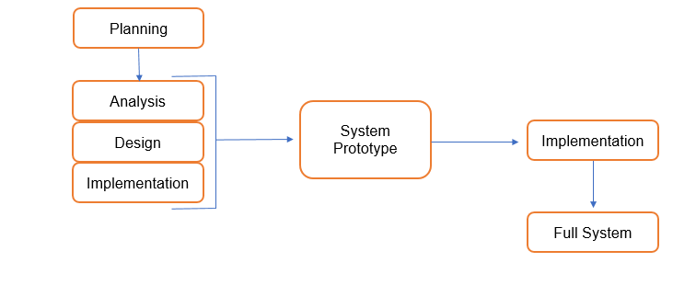

Figure Prototyping Methodology

**Planning:** The new system requirements are defined in as much detail as possible. For the proposed system, this involves interviewing a number of Healthcare givers representing all the departments or aspects of the existing system.

**Analysis and Design**: A preliminary, simple design is created for the new proposed system. This includes what shall be the basic components of the system that will lead to achievement of delegated objectives.

**Implementation:** A first prototype of the new system is constructed from the preliminary design. This is usually a scaled-down system, and represents an approximation of the characteristics of the final product.

The first prototype shall be evaluated and note its strengths and weaknesses, what needs to be added and what should be removed. The developer collects and analyzes the remarks from the users.

The first prototype shall be tested and then modified, based on the comments supplied by the users and the attainment level of its Objectives.

## 3.2 DATA COLLECTION

Data collection is the process of gathering and measuring information on targeted variables in an established system, which then enables one to answer relevant questions and evaluate outcomes. Data collection is a research component in all study fields, including physical and social sciences, humanities and business. The goal for all data collection is to capture quality evidence that allows analysis to lead to the formulation of convincing and credible answers to the questions that have been posted.

For the proposed system whose case study is at Jakaya two methods were used to collect the data that shall be analyzed and briefly give us the whole picture of the problem addressed above. The data collection method applied are:

* Questionnaires - research instrument consisting of a series of questions for the purpose of gathering information from respondents through survey or statistical study.

The questionnaires for this were used as a quick assessment on the nurses and doctors at Jakaya Kikwete Cardiac Institute.

* Interview - It’s a structured conversation where one participant asks questions, and the other provides answers.

Advantages of using Interview

* Provides flexibility to the interviewers
* The interview has a better response rate than mailed questions, and the people who cannot read and write can also answer the questions.
* The interviewer can judge the non-verbal behavior of the respondent.
* The interviewer can decide the place for an interview in a private and silent place, unlike the ones conducted through emails which can have a completely different environment.
* The interviewer can control the order of the question, as in the questionnaire, and can judge the spontaneity of the respondent as well.

### 3.2.1 AREA OF STUDY

Since the case study of the proposed system center itself within Jakaya Kikwete cardiac Institute. Through a careful study of this area of interest it was found that it has the following data:

* General wards can be occupied by 33 patients while the rest of the wards have a maximum capacity of 10 patients.
* There are 7 wards in total, of which 4 of which are for general, 2 are for Intensive care and 1 is for VIP.
* Both VIP and Intensive care have a maximum of 10 patient admission capacity.
* Healthcare givers have dayshift and night shift at which they do have to work, For nightshift 3 nurses and 1 health attendant are assigned to work onwards, and for a dayshift 5 nurses are in charge of the wards.
* There is a schedule for doctors that attends the patients in a day, where 2 doctors are actively in charge of the day (first call Doctors) and second on-call doctors are there for any emergency.

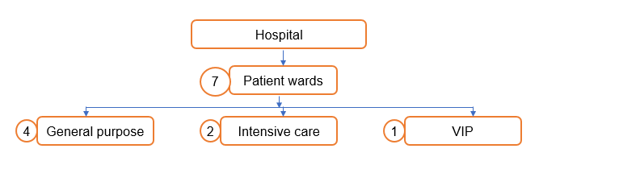

Figure Jakaya Kikwete Cardiac Institute

### 3.2.2 POPULATION AND SAMPLE SIZE

A population is a whole, it’s every member of a group. A population is the opposite of a sample size, which is a fraction or percentage of a group. Sometimes it’s possible to survey every member of a group. A classic example is the Census, where it’s the law that you have to respond. Note: if you do manage to survey everyone, it actually is called a census.

For this Project since the case of study is at Jakaya Kikwete Cardiac Institute where the population size of all the healthcare giver is around 15 that is doctors and nurses only . The sample size chosen for this project data collection is 10 healthcare givers.

### 3.2.3 QUESTIONNAIRE AND INTERVIEW RESULTS

The following are the overall results in pie charts of both questionnaire and interview questions which are generic to find the applicability and the need of the proposed system.

* The rating of satisfaction of the number of patients he/she serve in a shift

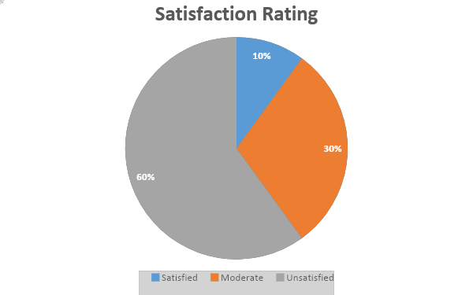

Figure Pie Chart 1

* The rating of satisfaction of the ways you use to assess patient temperature and pressure

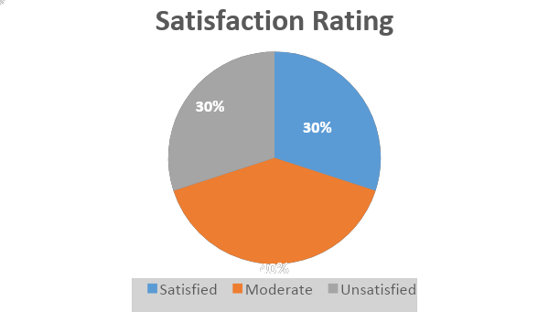

Figure Pie Chart 2

* The rating of satisfaction of the system under which the patient records are recorded

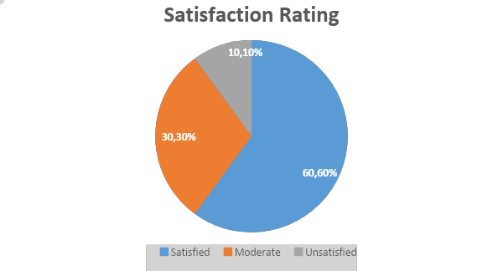

Figure Pie Chart 3

The patient records of the system are satisfying to most of the nurses since it's digital and makes it easy to manually write the paper work.

* The rating of satisfaction of Techniques used to respond to a patient critical condition 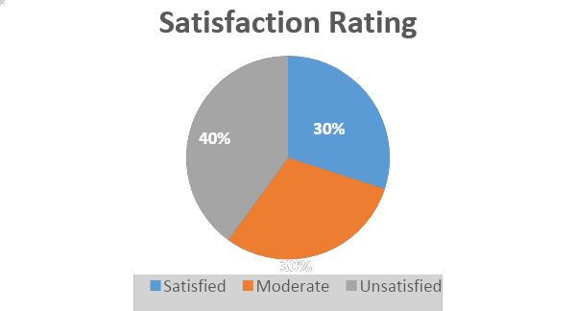

Figure Pie Chart 4

Since the current alerting system is not effective for the patient to notify the attending healthcare giver. The data shows that the majority of healthcare givers are not satisfied with the current model of alerting critical conditions.

* The rating of satisfaction of the idea under which the proposed system is going to handle the patient's temperature and pressure for you.

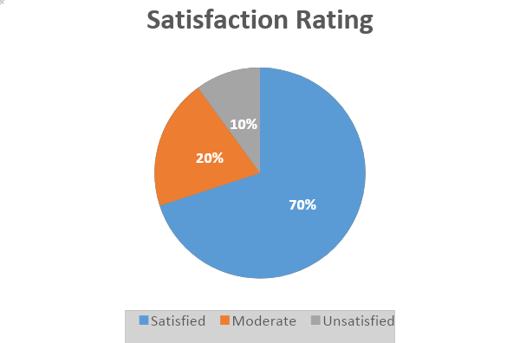

Figure Pie Chart 5

Here the majority agrees on the idea under which a proposed system is going to monitor the patient's health in a way that this system will make the patient monitoring activity be more effective in their daily work.

* The rating of satisfaction of the idea under which the patient records are going to be analyzed using artificial intelligence

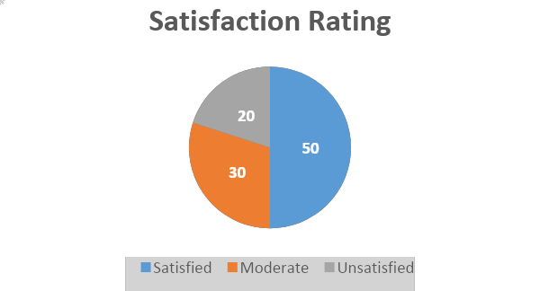

Figure Pie Chart 6

**Pie Chart 16**

Since the Majority of the healthcare givers agreed that the use of artificial intelligence systems and nonfictions would change their working experiences positively, then the proposed system is crucial.

## 3.3 SYSTEM ANALYSIS AND DESIGN

This is an organizational activity which focuses on identifying the procedures and requirements of the system to be built or developed. The process go through the four phases which are planning, analysis, design, and implementation

### 3.3.1 Software analysis and design

A software requirements specification (SRS) describes what the software will do and how it will be expected to perform. It also describes the functionality the product needs to fulfill all stakeholders (business, users) needs. For the case of this proposed system . The software part has both functional requirements and non functional requirements.

**Functional Requirement of the proposed system are**:

Table Functional Requirement

|  |  |  |
| --- | --- | --- |
| **No** | **Functional Requirement** | **Actor** |
| 1 | Registering patients admitted in wards | Healthcare giver |
| 2 | Registering Available active Sensor nodes | Healthcare giver |
| 3 | Recording and Monitoring Temperature and Heart rate | System |
| 4 | Alerting on critical condition defined | System |

**Non-Functional Requirement of the proposed system are:**

**Table 2 Non Functional requirement**

|  |  |
| --- | --- |
| **Non Functional requirement** | **Description** |
| **Availability** | It’s a web system hence with all possibilities would be available 24/7 . |
| **Usability** | System is user friendly, responsive, mobile friendly and it will be designed so that interaction of Healthcare giver will be maintained. |
| **Accessibility** | Since this system is mobile friendly and responsive so Healthcare giver will be able to access from every device with internet connection. |
| **Consistency** | To ensure consistency a system will use same CSS of bootstrap which are stable on almost all pages |

Use Case for the Proposed system. Use cases represent only the functional requirements of a system. Other requirements such as business rules, quality of service requirements, and implementation constraints must be represented separately, again, with other UML diagrams.

#### Proposed system Use Case.

Healthcare Giver

Node

System

Actors

Actors

**Figure** Use case

#### Software Development tools

1. **Python**

Python as a high-level, interpreted, general-purpose programming language. Its design philosophy emphasizes code readability with the use of significant indentation. Python is dynamically-typed and garbage-collected. It supports multiple programming paradigms, including structured (particularly procedural), object-oriented and functional programming. It is often described as a "batteries included" language due to its comprehensive standard library. This is chosen due to its flexibility on both data handling and manipulation using its libraries. For this project Python 3.10.4 Release is used. Python has a lot of framework for web applications development such as Django, Cherrypy, Flask and so on. For that case this project focuses on using Flask as a web framework to handle requests and provide the interface for both hard and software.

**Why Flask**

Flask was designed to be easy to use and extend. The idea behind Flask is to build a solid foundation for web applications of different complexity. From then on one is free to plug in any extensions he/she thinks they need. Also one is free to build their own modules. Flask is great for all kinds of projects. It's especially good for prototyping. Flask depends on two external libraries: the Jinja2 template engine and the Werkzeug WSGI toolkit. Flask has a lightweight and modular design, so it easy to transform it to the web framework you need with a few extensions without weighing it down ORM-agnostic: you can plug in your favorite ORM e.g. SQLAlchemy.Basic foundation API is nicely shaped and coherent. Flask documentation is comprehensive, full of examples and well structured. You can even try out some sample application to really get a feel of Flask

1. **Coding Tool Visual Studio Code Editor.**

Visual Studio Code is a lightweight but powerful source code editor which runs on desktop and is available for Windows, macOS and Linux. It comes with built-in support for JavaScript, TypeScript and Node.js and has a rich ecosystem of extensions for other languages (such as C++, C#, Java, Python, PHP, Go) and runtimes (such as .NET and Unity).

1. **Xampp for Local database management.**

XAMPP is a completely free, easy to install Apache distribution containing MariaDB, PHP, and Perl. The XAMPP open source package has been set up to be incredibly easy to install and to use. Using the PHP myadmin module of xampp the proposed project development and testing will be done locally which would help and stabilize the development process.

Since a proposed system is database driven, the final system that shall be deployed will use postgres to handle the patient data.



#### Database Design

Database design is the organization of data according to a database model. The designer determines what data must be stored and how the data elements interrelate. With this information, they can begin to fit the data to the database model.

For proposed system the data shall start with three models which are Patient Model

SensorNode and SensorRecords

Patient

Names

Condition Status

Assigned Doctor

Ward Number

Bed Number

SensorNode

SensorName

BedNo

WardNo

SensorRecord

Temperature

Heart-rate

Sensor_ID

Sensor_ID

Figure

### 3.3.1 Hardware analysis and design

#### System component

A system component is often a tool, utility, or another part of a big system that helps to manage different areas of that system. For the proposed system hardware these are three kinds of components which are Control unit , Sensors, Communication unit and Power supply.

#### Control unit

Control unit of the proposed system consists of a **Node MCU** - NodeMCU is an open source Lua based firmware for the ESP8266 WiFi SOC from Espressif and uses an on-module flash-based SPIFFS file system. NodeMCU is implemented in C and is layered on the Espressif NON-OS SDK. There are several releases of node MCU but for the project ESP 8266 is to be used.

#### Node MCU Technical Specifications.

Table Node MCU Technical specifications

|  |  |  |  |
| --- | --- | --- | --- |
|  | **Official NodeMCU** | **NodeMCU Carrier Board** | **LoLin NodeMCU** |
| **Microcontroller** | ESP-8266 32-bit | ESP-8266 32-bit | ESP-8266 32-bit |
| **NodeMCU Model** | Amica | **Amica** | Clone LoLin |
| **NodeMCU Size** | 49mm x 26mm | 49mm x 26mm | 58mm x 32mm |
| **Carrier Board Size** | n/a | 102mm x 51mm | n/a |
| **Pin Spacing** | **0.9" (22.86mm)** | **0.9" (22.86mm)** | 1.1" (27.94mm) |
| **Clock Speed** | 80 MHz | 80 MHz | 80 MHz |
| USB **to Serial** | CP2102 | **CP2102** | CH340G |
| **USB Connector** | Micro USB | Micro USB | Micro USB |
| **Operating Voltage** | 3.3V | 3.3V | 3.3V |
| **Input Voltage** | 4.5V-10V | 4.5V-10V | 4.5V-10V |
| **Flash Memory/SRAM** | 4 MB / 64 KB | 4 MB / 64 KB | 4 MB / 64 KB |
| **Digital I/O Pins** | 11 | 11 | 11 |
| **Analog In Pins** | 1 | 1 | 1 |
| **ADC Range** | 0-3.3V | 0-3.3V | 0-3.3V |
| **UART/SPI/I2C** | 1 / 1 / 1 | 1 / 1 / 1 | 1 / 1 / 1 |
| **WiFi Built-In** | 802.11 b/g/n | 802.11 b/g/n | 802.11 b/g/n |
| **Temperature Range** | -40C - 125C | -40C - 125C | -40C - 125C |
| **Product Link** |  | NodeMCU | NodeMCU |

#### Sensors and 16x2 LCD Display

Sensors mines the data from a patient under which a patient is to be monitored.For the proposed system Temperature and Heart rate sensor shall be used. For measuring the temperature of the patient DS1820 will be used. The DS1820 is a 1-wire programmable Temperature sensor from Maxim integrated. It is widely used to measure temperature in hard environments like in chemical solutions, mines or soil, etc. It can measure a wide range of temperature from -55°C to +125° with a decent accuracy of ±5°C. Next is the heart rate sensor which captures the heart pulse of the patient. A pulse wave is the change in the volume of a blood vessel that occurs when the heart pumps blood, and a detector that monitors this volume change is called a pulse sensor. First, there are four main ways to measure heart rate: electrocardiogram, photoelectric pulse wave, blood pressure measurement, and phonocardiography. Pulse sensors use the photoelectric method. Finally is the 16x2 ic2 LCD Display which will show both temperature and heart reading of the patient whose node is attached to. LCD display shall be the first interface for the health care giver to monitor and determine the temperature and heart rate of the patient.

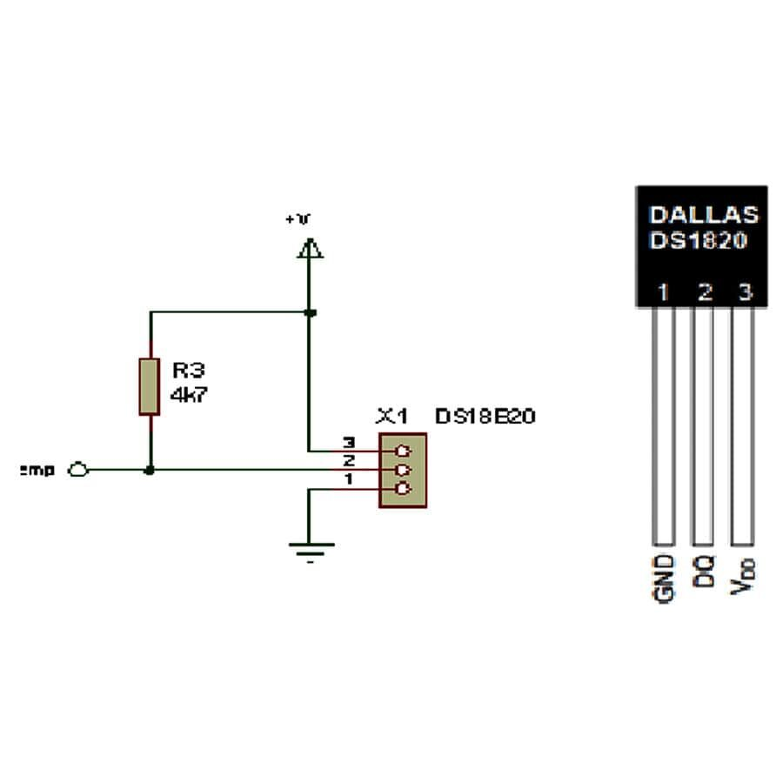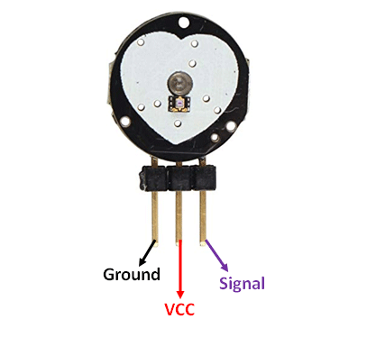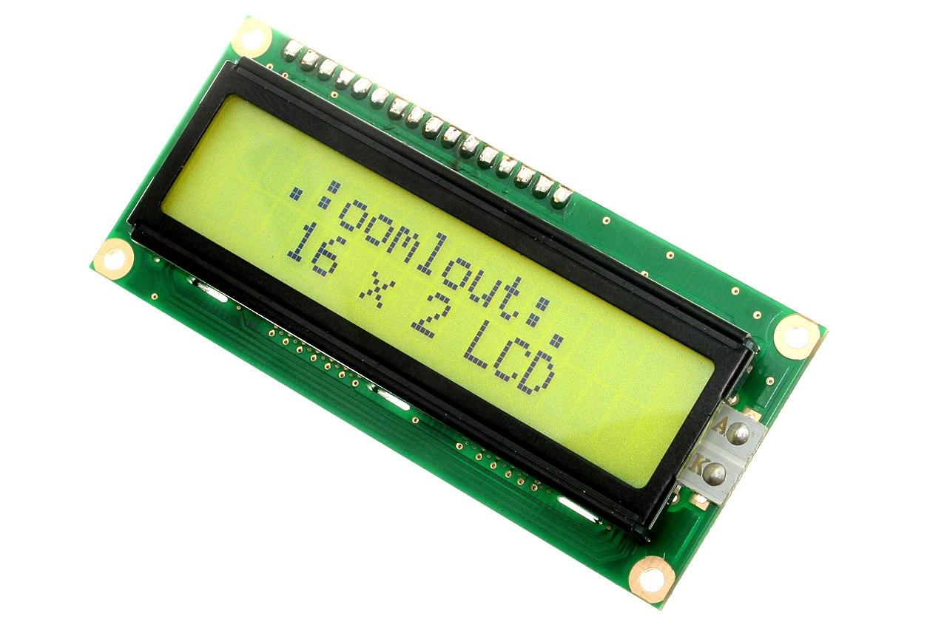

Figure Figure Figure

#### Power supply and Connectors :

The proposed system shall be supplied with a 12V charger. Circuit will involve a drop in voltage from 12V to 5V then 3V. 5V shall be used by sensor and LCD display while the Node MCU will consume 3.3 Volts .

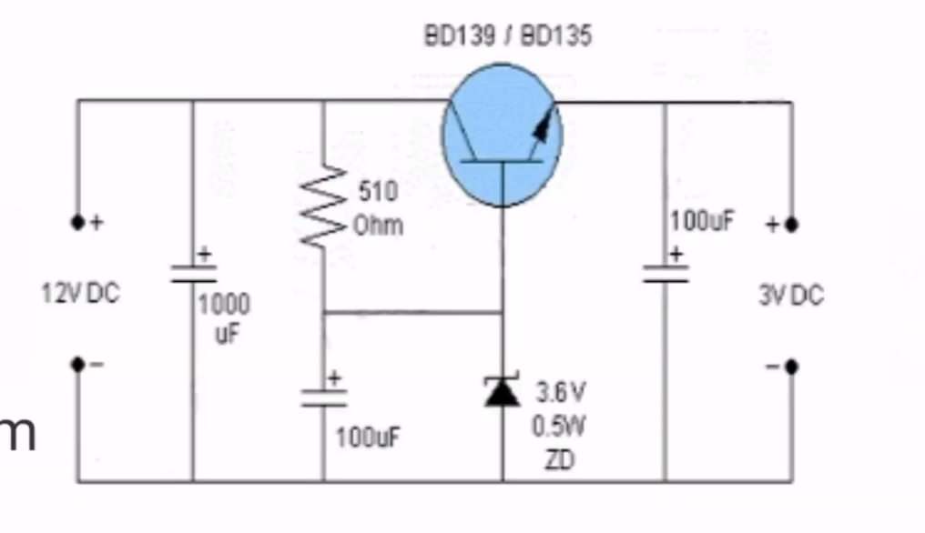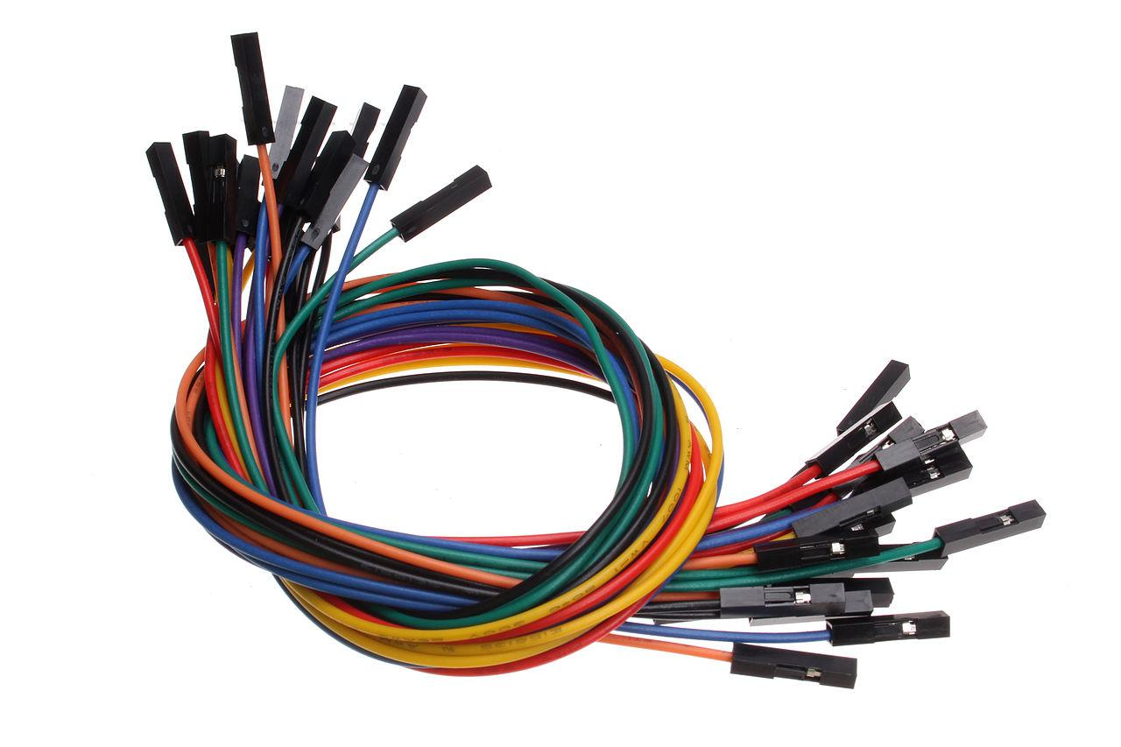

Figure Figure

#### Enclosure Design

Designing enclosures is one of the most important parts of product development. Enclosures are the skin of the product and the part we usually interact with. They need to be highly functional and at the same time attractive and easy to handle. For the proposed system the enclosure shall consist of Node MCU and outlet of LCD display and power cables. Second Design shall be for the finger holder of sensors that is temperature and heart rate Seno

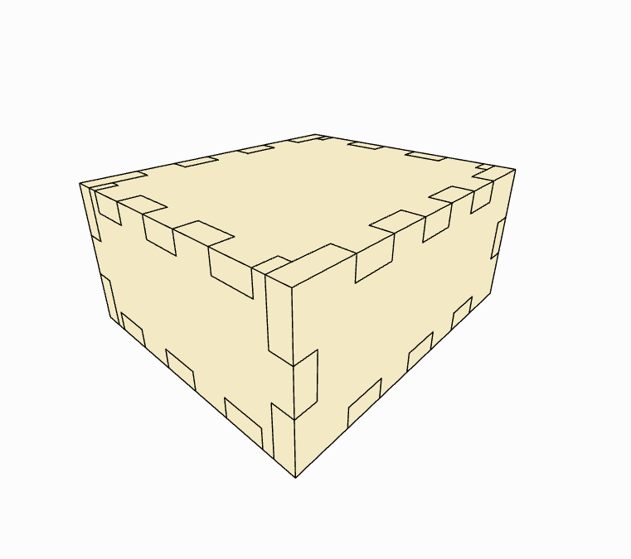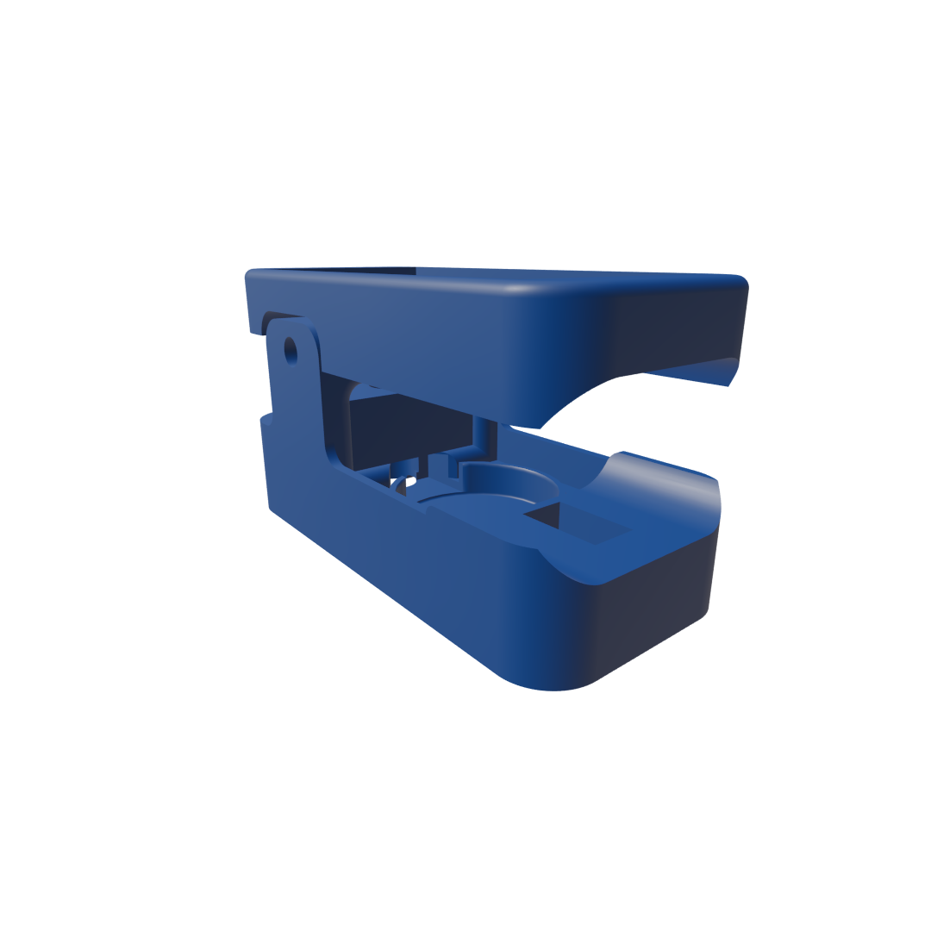

Figure Figure

### 

## 3.3 CHAPTER SUMMARY

This chapter presents data collection methodology, area of study, population, sample size and data analysis of the data collected using mentioned data collection techniques. The area of study for this project is Jakaya Kikwete Cardiac Institute. The data collection techniques used for this project were questionnaire and interviews. The population for healthcare giver of this project were 15 healthcare givers where the sample size were 8 nurses and 2 medical doctors. Interview questions and questionnaire responses show that most of the healthcare givers are not satisfied with the current system and most agree with the idea of imposing the new system of monitoring the temperature and blood pressure of patients in award.

# CHAPTER FOUR

## 4.0 SYSTEM IMPLEMENTATIONS

Systems implementation under this procedure is to ensure that the proposed system is operational and used, ensuring that the proposed system meets quality standards of its performance. Involves gathering all the tools and set of parts of the system to interconnect and build its structural functionality. For the proposed system , system implementation involves both Software and hardware development.

### 4.0.1 SOFTWARE IMPLEMENTATION

Software implementation process involves integrating an application into an organization's workflow. The process typically begins with organizing the software tools such as IDE or text editor configuration, Language and libraries, Framework environment for the smooth workflow during software development. It includes installing and updating the application, migrating data and testing various features.

Installation of Flask, Python and pip package manager is the first step toward building this web application for the proposed system. The flask application consists of import python modules and simply the defined route under which the system allows the view for the different resources. 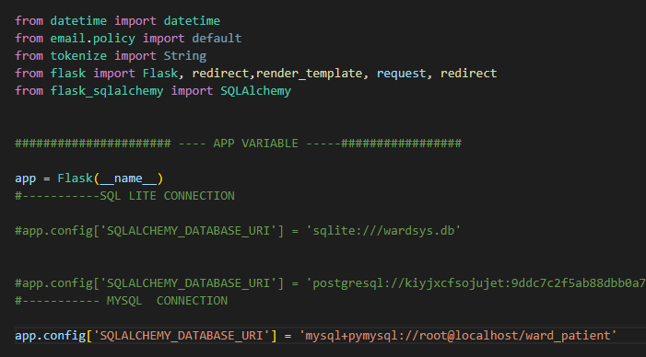

Figure

For the proposed system the views use jinja2 , bootstrap framework for HTML 5 and CSS cascades for styling the views.

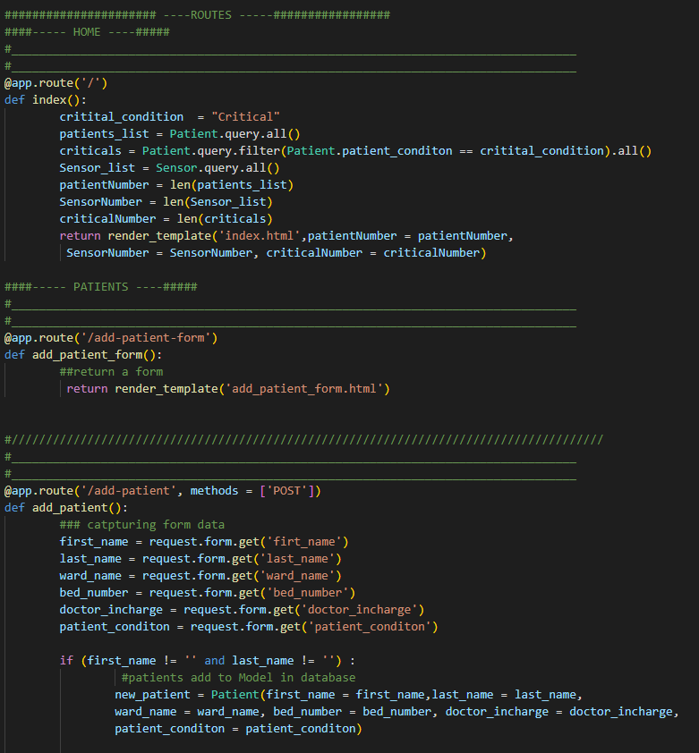

Figure

Since Flask is a framework that works under MVC structure python uses SQL alchemy as a format for handling the system models and Controllers are methods defined and bound to the routes of the views.



Figure

Lastly the view which shows the home page and all its content, developing form for registering patient and sensor nodes and tables for view list of admitted patients and their temperature and heart rate status.

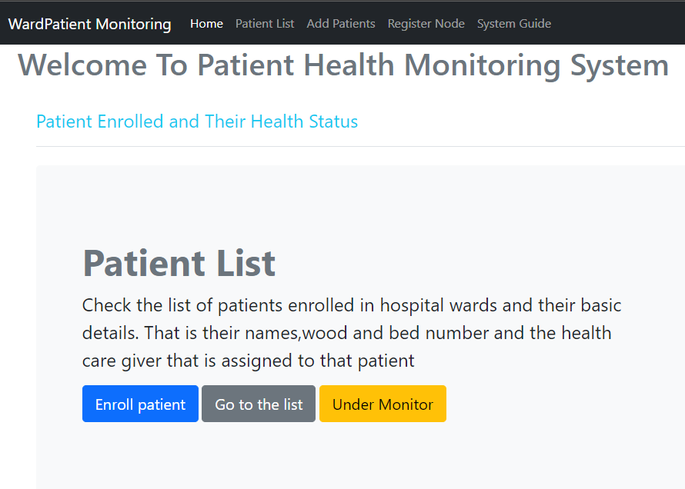

Figure

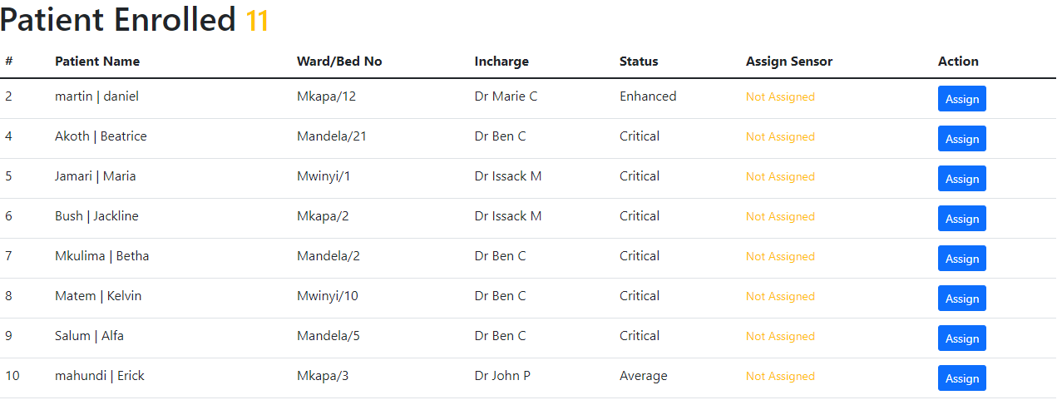

Figure

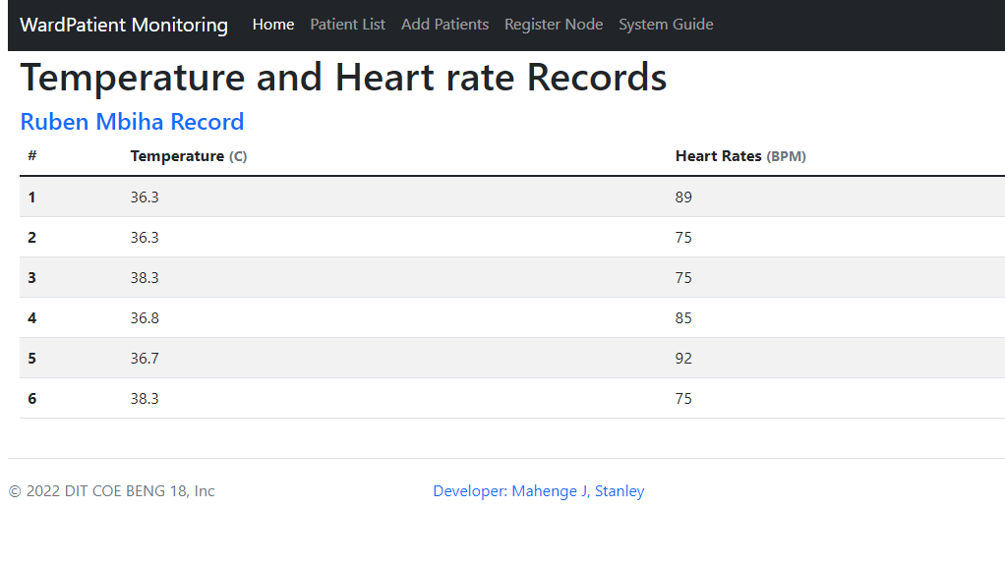

Figure

Web app of the system is deployed in Heroku using the github repository. Heroku is a platform as a service (PaaS) that enables developers to build, run, and operate applications entirely in the cloud. Link for the prototype is [*https://monitorsystem.herokuapp.com*](https://monitorsystem.herokuapp.com)

and github repository is [*https://github.com/StanAdim/Patient-Monitor*](https://github.com/StanAdim/Patient-Monitor)

### 4.0.2 HARDWARE IMPLEMENTATION

Hardware implementation process involves integrating system components and tools into an organization's workflow. The process typically begins with simulation of the proposed system and organizing the software tools such as IDE or text editor configuration and libraries, Connecting the tool in the circuit for the smooth communication and power transmission of all the system components. It includes programming microcontrollers with logic that governs all the other components of the proposed system.

Simulation for the proposed system is done by Proteus.

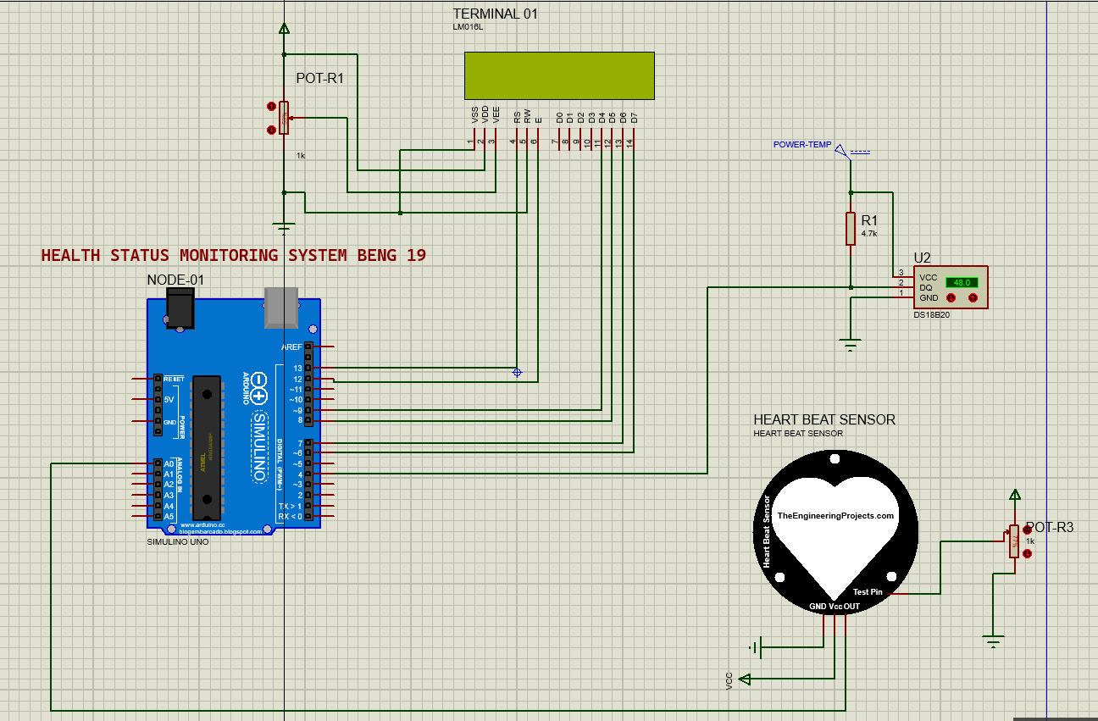

Figure

The simulation is done using Arduino UNO even though the microcontroller used at the end is the node MCU because of wifi capability to connect to the internet.

Furmore is building the component of the system from individual components and design of the system. Building the case from case design and lather cutting it. The case would be able to contain all the inner components of the proposed system and holder of the sensors.

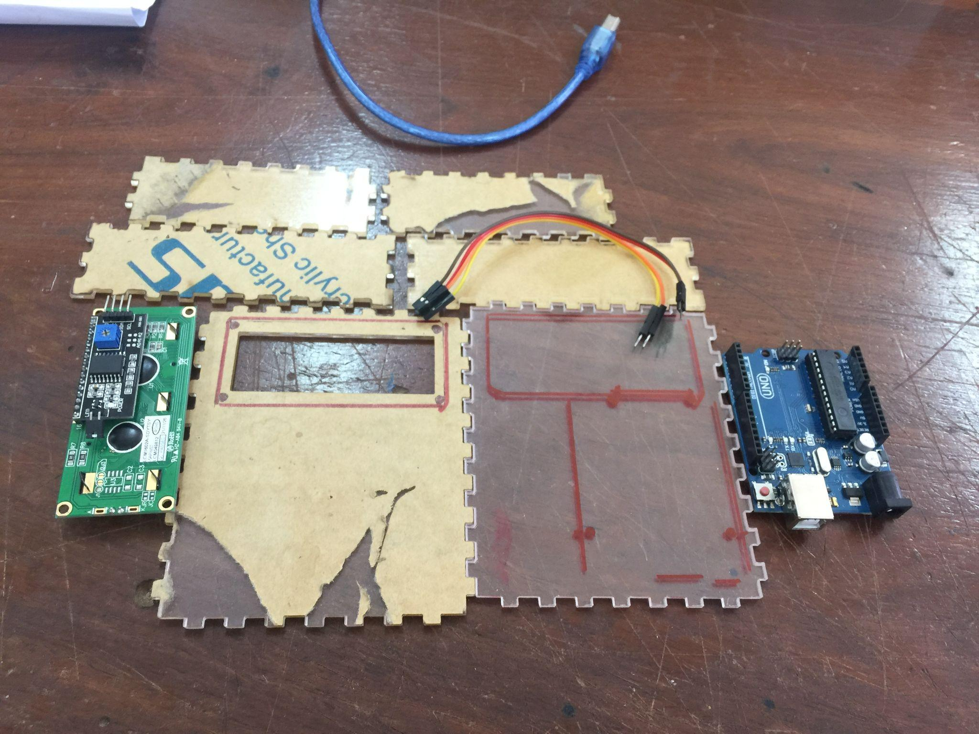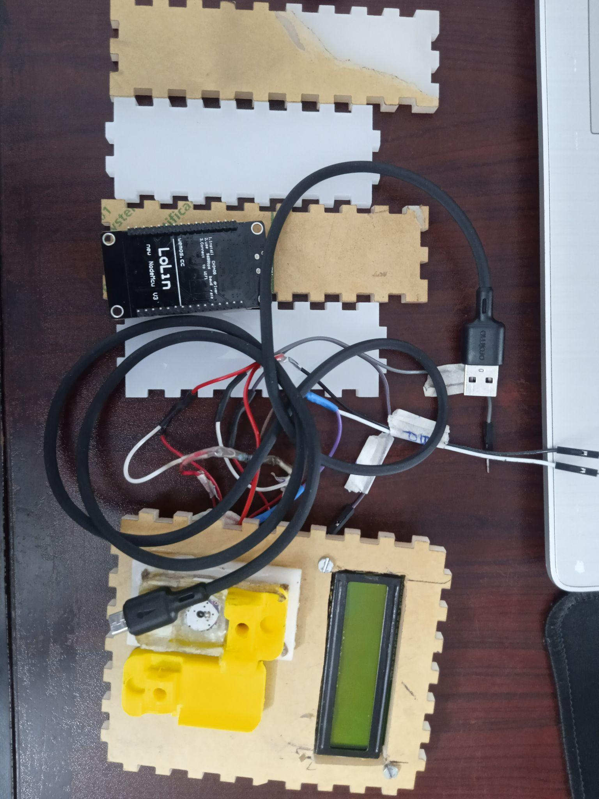

Figure

Programming the microcontroller for it to be able to control the LCD display, Temperature and heart rate Sensor. Initially the required libraries are initiated followed by variable declaration then setup function which initiates the node and tests the internet connection.Arduino IDE is use to program the microcontroller

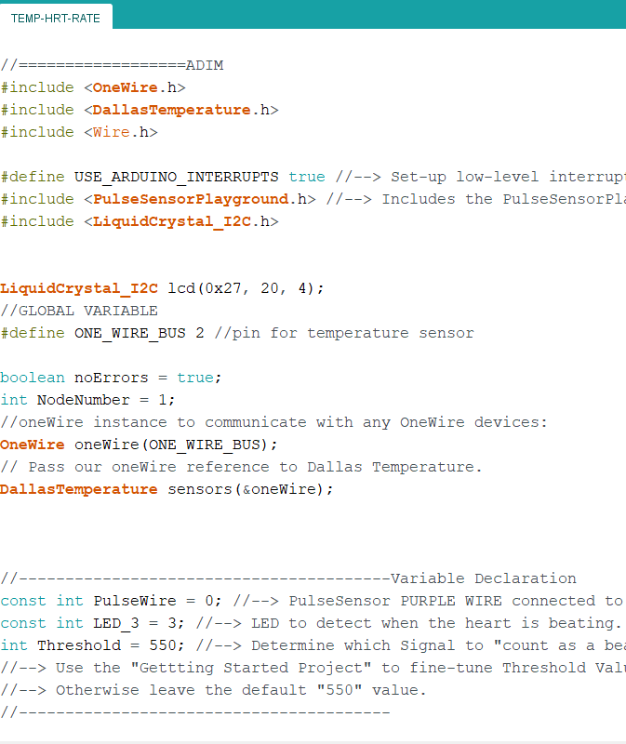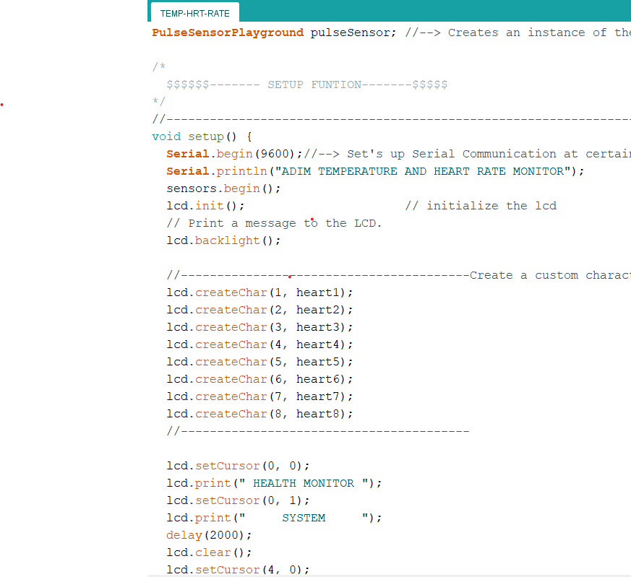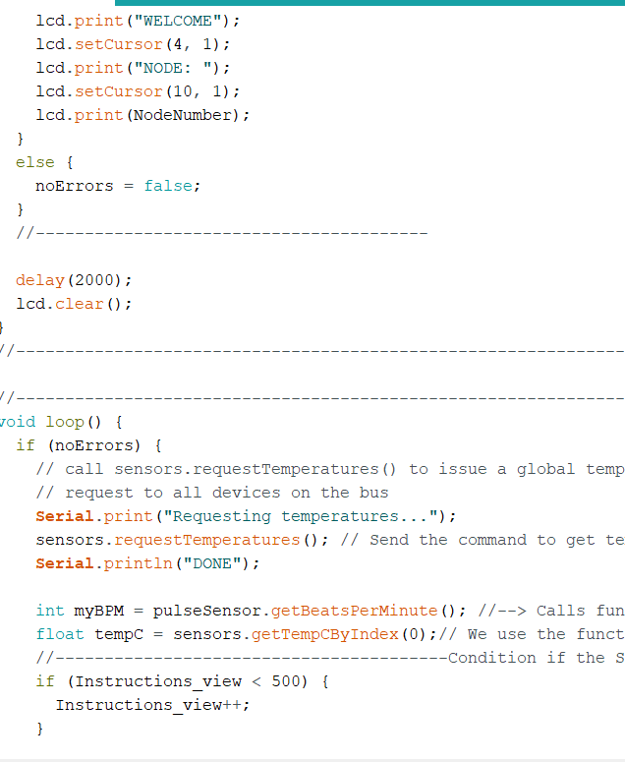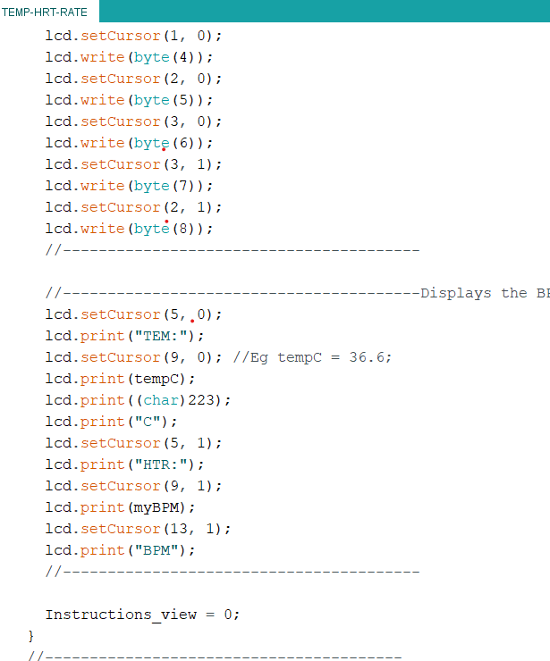

Figure

## 

## 4.1 RESULTS AND DISCUSSIONS

The result of the system is based on the sensor node prototype to measure the temperature and heart rate of the patient and send the record to the web based system that monitors both the temperature and heart rate. The node should be able to display the temperature and heart rate of the patient, this helps the healthcare giver to track the patient status directly.

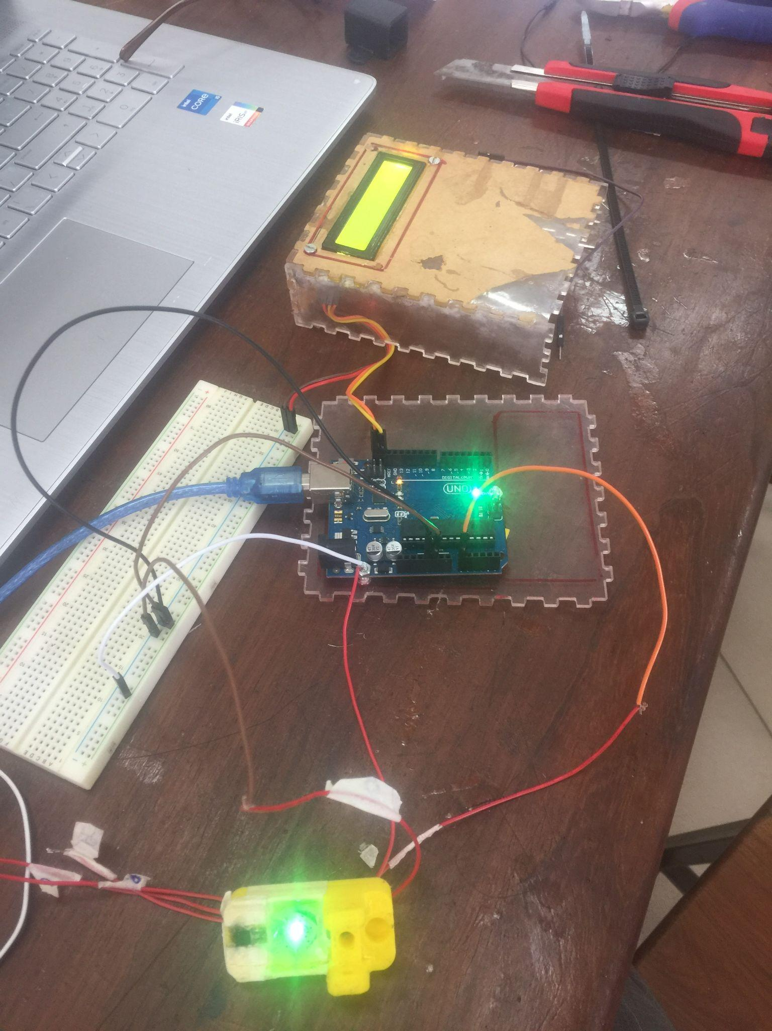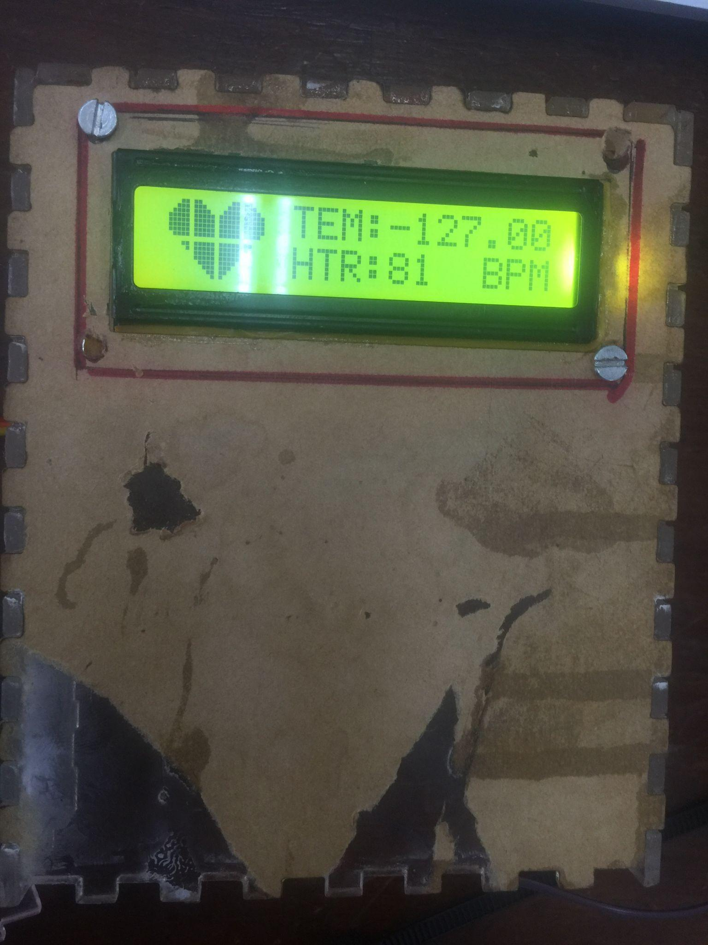

Figure

## 4.2 CHAPTER SUMMARY

This is an interesting part of the project since it involves all the necessary skills and practice, it's where the whole idea of the proposed project is brought to life tangibly.From reading the designs, assembling the component ,programming the microcontroller, coding the web application and finally deploying the application as fully functional system.

# 

# CHAPTER FIVE

## 5.0 RECOMMENDATION AND CONCLUSION

This report provides information concerning the existence of the current system of patient monitoring at Jakaya Kikwete Cardiac Institute and addresses the problems associated with that system. The recommendation of this proposed system is such that temperature and heart rate of patients while they are admitted in a ward should be using technology such as the internet of things and artificial intelligence to monitor all the patients under critical conditions.

Therefore the effective use of this system would reduce the heavy burden of healthcare and consequently improve the quality of protecting lives through the use of technology to ensure humanity's prosperity and good life.

## 5.1 PROJECT COST ESTIMATION

The costs associated with the development of these projects are categorized in two groups which are equipment and stationeries. Some of the equipment was ordered abroad but all the stationery paperwork was held at the institute.

The table below shows the total costs involved in producing this prototype. For devices that were purchased abroad using foreign currency, I have converted the amount to Tanzanian shillings in the table to obtain the total amount.

**COST ESTIMATION Table 1**

Table Cost Estimation

|  |  |  |  |
| --- | --- | --- | --- |
| S/N | Cost for | ACTIVITY | Cost |
| 1 | Internet | Literature review, research, online tutorial computation. | 30,000 |
| 2 | AI-based Web portal design | For storing and displaying the patient records | 120,000 |
| 3 | Transport | Moving to and from the site of research and data collection. | 20,000 |
| 4 | Stationery | Printing and binding the report | 15000 |
| 5 | Arduino (2) | 1 for encoding data and 1 for decoding data | 70,000 |
| 6 | GSM Module (1) | For sending SMS and notification to the user | 50,000 |
| 7 | Temperature and Pressure Sensor | For mining that patients data | 90,000 |
| 9 | Miscellaneous | Extra tools and | 5000 |
| 8 | NRF24 (2) | For communication facility | 50,000 |
| Total | | | 450,000 |

## 5.2 ESTIMATED TIMELINE

The timeline that has been handling and shall be handling the process of building the prototyping for the proposed project is as follows.

**TIMELINE OF PROJECT Table 2**

Table Project Timeline

|  |  |  |  |  |  |  |  |  |  |  |  |  |  |  |  |  |
| --- | --- | --- | --- | --- | --- | --- | --- | --- | --- | --- | --- | --- | --- | --- | --- | --- |
|  | **PROJECT DURATION IN WEEKS** | | | | | | | | | | | | | | | |
|  | 1 | 2 | 3 | 4 | 5 | 6 | 7 | 8 | 9 | 10 | 11 | 12 | 13 | 14 | 15 | 16 |
| Data collection |  | |  |  |  |  |  |  |  |  |  |  |  |  |  |  |
| implementation |  | | | | | | | | | | | | | | |  |
| Data analysis |  |  |  | | | | |  |  |  |  |  |  |  |  |  |
| Defending the  project |  |  |  |  |  |  |  |  |  |  |  |  |  |  |  |  |
| System analysis  and design |  |  |  |  |  |  |  |  |  | | | | |  |  |  |
| Presentation  min two |  |  |  |  |  |  |  |  |  |  |  |  |  |  |  |  |
| Report writing,  submission and |  |  |  |  |  |  |  |  |  |  |  |  |  |  |  | |

# REFERENCE

[1] Kadhim, Kadhim Takleef; Alsahlany, An Overview of Patient's Health Status Monitoring System Based on Internet of Things (IoT).Wireless Personal Communications . Oct2020, Vol. 114

[2] Jemal H. Abawajy; Mohammad Mehedi Hassan, Federated Internet of Things and Cloud Computing Pervasive Patient Health Monitoring System, IEEE,January 2017.

[3] C. A. McHorney & A. R. Tarlov, Individual-patient monitoring in clinical practice: are available health status surveys adequate ,Published: August 1995

[4] R. Kumar; M. Pallikonda Rajasekaran ,An IoT based patient monitoring system using Raspberry Pi, IEEE,October 2016.

[5] M. Shamim Hossain, Patient status monitoring for smart home healthcare, 2016 IEEE International Conference on Multimedia & Expo Workshops